GINA L. SILLITTI  16TH Assembly District | THE ASSEMBLY  STATE OF NEW YORK  ALBANY | CHAIR  Subcommittee on Occupational Licenses  COMMITTEES  Economic Development, Job Creation, Commerce and Industry  Election Law Governmental Employees Labor  Tourism, Parks, Arts and Sports Development Transportation  MEMBER  Legislative Women’s Caucus Task Force on Women’s Issues
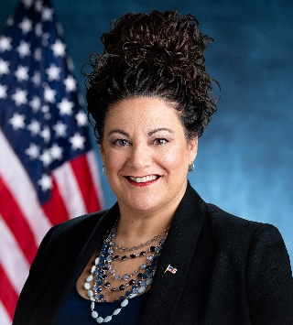
May 4, 2023

Dear Friends,

I am delighted to congratulate Hofstra University on the occasion of its annual scholarship fundraising Gala, and I want to recognize honoree Dr. Kathleen Gallo for her outstanding contributions in the healthcare community at large.

Dr. Gallo is a pioneering leader in healthcare, interprofessional education, and organizational learning. As the founding dean of the Hofstra Northwell School of Nursing and Physician Assistant Studies, Dr. Gallo’s work has contributed significantly to the school’s accomplishments and advancement. With her new role as Executive in Residence, there is no doubt Dr. Gallo will provide innovative curriculum development, mentorship, and counsel. Dr. Gallo is paving the way for future healthcare leaders to achieve remarkable success. Her perseverance and dedication towards community-based care are deeply appreciated in the community.

I wish you a wonderful night in celebration of education and in honor of Dr. Kathleen Gallo, a woman who is invaluable to the world of healthcare and education.

Warmest Regards,

Gina L. Sillitti
New York State Assembly
District 16

