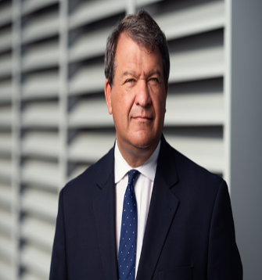
June 5, 2024

Dear Friends,

It is my great honor to join with the Westchester Jewish Center (WJC) in celebration of their Spring Gala and in congratulating their honorees. Westchester Jewish Center is a conservative, traditional, egalitarian synagogue in Mamaroneck. They are a welcoming and supportive community that provides a wide array of programs and services through their Religious Schools and Adult Education. WJC also contributes to community causes such as the Mamaroneck Food Pantry, The Community Resource Center, New Rochelle’s Hope Community Services and many other initiatives and organization in Westchester County.

I extend my sincere congratulations to your exemplary honorees: Jonathan Berg and Joanna Liebman. These friends and congregants of the WJC are a true example of living life in service to others. They have contributed time, talents, skills, effort, and experience to the Center and the surrounding community, thereby highlighting their extraordinary service to WJC.

Jonathan Berg has been a stalwart member of WJC for over ten years, and has taken on many responsibilities at WJC, including Co-chairing the Family, Youth, Education Committee (FYEC), a Trustee and Officer, serving on the Membership Committee, establishing the Just Older Youth (J.O.Y.), club, co-chair of WJC’s Strategic Committee and many others.

Joanna Liebman has been a committed and dependable member of WJC for over nine (9) years. She is a Trustee and Chair of the Strategic Plan Committee that has fostered WJC mission of a community of “belonging and welcome to all Jews seeking to share and enrich its spiritual, religious and cultural experiences.” She has worked diligently to ensure an inclusive environment at WJC.

Your esteemed honorees are the embodiment of the humanitarian spirit and of unparalleled commitment and dedication to Westchester Jewish Center. Their continued and persistent selfless devotion to helping others has significantly impacted not only the center, but also its congregants and the entire Westchester County community.

Best wishes to Westchester Jewish Center and may you have for a wonderful Spring Gala!

Sincerely,
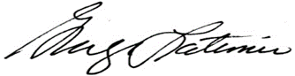
George Latimer
Westchester County Executive

